# User Manual for Sydney Airbnb

Welcome to Sydney Airbnb, a powerful tool for analysing real estate data. This user manual will guide you through the software's features, complete with informative screenshots for a better understanding.

Table of Contents

User Manual for Sydney Airbnb 1

1. Getting Started 2

1.1. Installation 2

1.2. Launching the Software 2

1.3. User Interface Overview 2

1.3.1. Report All Listing 2

2

1.3.2. Display Prices 2

1.3.3. Search Keyword 3

1.3.4. Retrieve Count (Mentioning the Keyword) 3

1.3.5. Total Number of Bedrooms (In Apartment) 4

4

2. Settings and Support 4

2.1. User Preferences 4

2.2. User Data Storage 4

# 1. Getting Started

## 1.1. Installation

Download and install Sydney Airbnb from the official website or your app store.

## 1.2. Launching the Software

Upon installation, launch the software. You will be greeted with the welcome screen.

## 1.3. User Interface Overview

### 1.3.1. Report All Listing

The first screen that the users will come across will be the following screen.

The user can then input the suburb and search for the specified time range.

Clicking the button “Generate Report”.

Figure : Report All Listing

### 

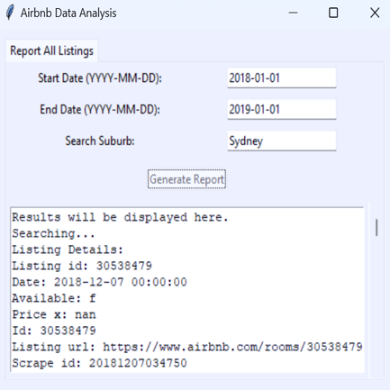

The output obtained would be a list of all the properties in that specific suburb for the provided time period.

### 

Figure : Report All Listing Output Display

### 1.3.2. Display Prices

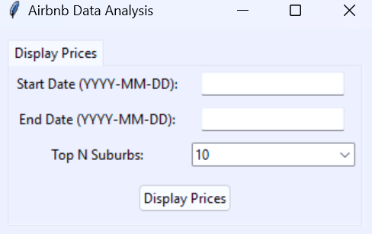The following display will focus on the price displays.

The input that the user needs to add would be the number of suburbs they are targeting to look for the provided time range they have provided.

Figure : Price Display (User Input Display)

After entering the input, they can click on the button “Display Prices”.

There is a graphical output representing the number of top suburbs as selected against the mean price for the given date range.

Figure : Figure 3: Price Display (Output for given dates)

### 1.3.3. Search Keyword

The user can input multiple keywords separated by a comma (e.g., pool, pet) to customise their search for specific qualities in a property. This search is also time range specific, so the user needs to specify it. 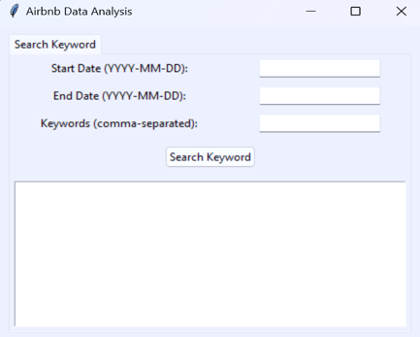

After inputting the details, they can click on the button “Search Keyword”.

Figure : Search Keyword

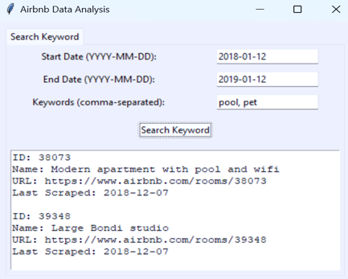

The output is displayed in a list format displaying the property ID, name, and URL to investigate it deeper.

Figure : Search Keyword (Output Display)

### 1.3.4. Retrieve Count (Mentioning the Keyword)

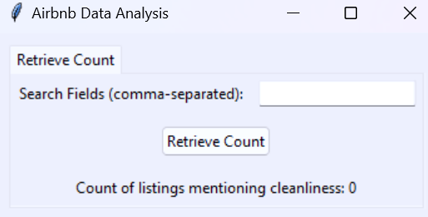

The user will input the Keyword.

Clicking on the button “Retrieve Count”.

The total number of properties having the specified Keyword (e.g., spotless) will be displayed.



Figure : Retrieve Count for Keyword Searched

121093



Figure : Display Total Counts with Keyword

### 1.3.5. Total Number of Bedrooms (In Apartment)

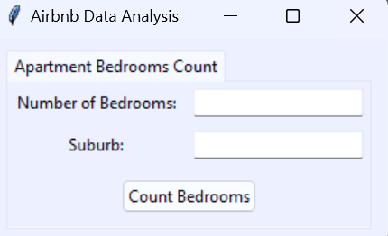The user will input the suburb they are interested in and the required number of bedrooms.

Clicking on the button “Count Bedrooms”.

The output result will be displayed figure 10.

Figure : Total number of Bedrooms in Apartment

Figure : Output for the total Number of Bedrooms

# 2. Settings and Support

## 2.1. User Preferences

Adjust your user preferences, including notifications and appearance, in the profile section.

## 2.2. User Data Storage

The data inputted will be stored in our database to provide more accurate results in the future.